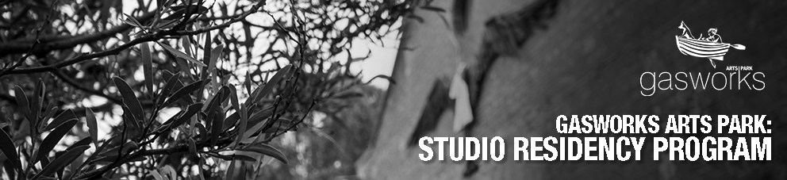
Studio Residency Program
The Gasworks Arts Park Studio Residency program is a professional development opportunity to incubate new projects during a 10 week residency on site. These projects will also be assessed by the panel for their potential to be presented publicly at Gasworks Art Park in the future.

The studios are located on 3 hectares of enclosed parkland 6kms from Melbourne’s CBD in the bayside suburb of Albert Park. Our artistic community is comprised of 15 professional artists working on site in sculpture, ceramics and other genres in the visual arts. The artists are all active participants in a community development program for the City of Port Phillip, including monthly Open Studio days during our renowned Farmers Market. Gasworks Arts Park is also home to 2 galleries, 2 theatres, a workshop facilitation studio and an Arts & Crafts space for hire. There is a café on site and the closest tram stop is 300m away.

The studio space for these residencies will be available for 3 of the following days; Tuesday, Wednesday, Thursday and Friday from 10am – 4pm for 10 weeks. Applications are now available for residencies commencing at the beginning of July and October 2021.

The residency will enable the development of studio practice, collaboration and creative conversations with peers in addition to mentoring and career guidance from the GAP management and marketing team. The studio space on offer will accommodate an individual artist in a shared building with 3 other full time professional artists in separate studios.
Art practices for consideration by the panel can include: Painting
Printmaking
Small sculpture projects Jewelry
Leatherwork Collage Playwriting
Online digital projects Workshop Development

Studio Residency Program
Objectives

This Studio Residency program has been created to provide emerging and mid career artists with free studio space and a cash stipend to continue developing their practice in return for the opportunity to contribute to the community through creative engagement and collaboration.

For each residency the artists will receive the sum of $1500 to contribute towards the cost of transport, food and beverage and materials.

Outcomes for artists:

Connection to City of Port Phillip based arts programs, networks and communities Collaboration with peers and artists with diverse practices
Free studio space and artistic exchange
Mentorship and professional development opportunities
At the end of each residency there will be an opportunity to present your incubated project to the panel for potential further support by Gasworks Arts Park in the form of an invitation to exhibit, free audition and/or rehearsal periods or an invitation to be part of a children’s holiday workshop series.
Featured article at the end of your residency in one of our monthly e-newsletters with 8500+ subscribers

The Studio Residency Program at Gasworks Arts Park is generously supported by the Gasworks Patrons and Friends Foundation

Applying for the Studio Residency
Application process:

Support material to submit:
- Completed online application form
- 6 to 10 images of artworks in one document (maximum 3 pages)
- Professional CV including a referee contact who can provide substantiating information about your arts practice

Your submission will be assessed on:
- The suitability of the concept to be presented publicly at Gasworks Arts Park.
- Artistic and aesthetic strength of individual practice.
- The demonstration of strong communication skills.
- The ability to work flexibly to realise artistic outcomes.

Your Expression of Interest will be reviewed by a panel consisting of the Chief Executive Officer, the Visual Arts & Studio Manager and a current Artist in Residence.

If you have more information you would like to submit or have any questions about applying, please contact the Gasworks' Visual Arts and Studio Manager at visarts@gasworks.org.au

The first Expressions of Interest are for residencies commencing at the beginning of July and October 2021.
EOI submissions must be received by Sunday, June 6 2021 and applicants will be notified of the outcome of the within two weeks.

The Studio Residency Program at Gasworks Arts Park is generously supported by the Gasworks Patrons and Friends Foundation.

Your information
- 1. Please enter your details

Name:

Address:

Suburb:

State:

Postcode:

Email:

Phone Number:

Website (if applicable):

  - Please upload your CV
Please attach a professional CV, including a referee contact who can provide substantiating information about your arts practice.

Choose File Choose File No file chosen

  - Please upload 6 to 10 images of your artworks. In one document, maximum 3 pages.
Choose File Choose File No file chosen

  - (Optional) Please upload an artist bio

Choose File Choose File No file chosen

Your project
- What is the working title of your project?

- What is the genre of your project or art form?
Painting Printmaking
Small sculpture project Jewelry
Leatherwork Collage Playwriting
Online digital project Workshop development
Other (please specify)

- Please describe your project in 100 words or less

Studio use
8. Which items will you need to bring to the studio, and please state for each one if they are removable each day or must stay in situ for the 10 weeks.
Item 1:

Item 2:

Item 3:

Item 4:

Item 5:

Item 6:

Item 7:

Item 8:

Item 9:

Item 10:

Additional Items:

- 9. Please nominate which three studio days of the four available you would like to be in residence.
Tuesday Wednesday Thursday Friday
Further comments:

- 10. Which residency are you applying for?
October 2020

March 2021

Final Page
Thank you for submitting an application for the Studio Residency Program.

If you have more information you would like to submit or have any questions about applying, please contact the Gasworks' Visual Arts and Studio Manager at visarts@gasworks.org.au

The Studio Residency Program at Gasworks Arts Park is generously supported by the Gasworks Patrons and Friends Foundation

